ACFP AWARDS PROGRAM NOMINATION FORM

Patient’s Medical Home outstanding family practice Award
The Alberta College of Family Physicians (ACFP) annual Awards Program recognizes the outstanding commitment and dedication of its members. Please complete the following nomination form in its entirety as incomplete forms will not be accepted.
Nominations are due April 1, 2025, and may be sent via mail, email, or fax to:
Alberta College of Family Physicians
#370, 10403–172 Street
Edmonton, AB T5S 1K9
Email: ACFPAwards@acfp.ca
Telephone: (780) 488-2395
Fax: (780) 488-2396

nominee information
Name of Practice/Clinic:

First and Last Name of Primary Contact:

Clinic Address - City/Province /Postal Code:

Primary Contact Phone Number: | Fax Number:
Email Address:

nominator information
First and Last Name of Nominator:
Preferred Address (Home/Office) – City/Province/Postal Code:

Phone Number:

Email Address:

Signature:

Patient’s Medical Home Award – Nomination Form

AWARDS CRITERIA and Attestation
As a chapter of the College of Family Physicians of Canada, the ACFP supports the vision of a Patient’s Medical Home (PMH). Rooted in the trusted relationships fostered between patients and family physicians, the PMH model promotes a team-based approach to the delivery of comprehensive and compassionate patient-centred care and is considered the future of family practice in Canada.

The Patient’s Medical Home – Outstanding Family Practice Award recognizes family practices and/or clinics across the province that are actively modeling or pursuing the implementation of one or more of the 10 PMH Pillars (identified on the following page). This award is based on peer nominations, members of the public, or are self-nominated and all who meet eligibility are welcome to submit a nomination.
Eligibility Criteria
- The nominee has been in practice for a minimum of two years (i.e., the family practice or clinic has been in operation for at least two years)
- Candidates may be recognized for their exemplary implementation of the PMH Pillars
- Candidates may be recognized for demonstrating their adaptative, innovative, resourcefulness, and resiliency in pursuit of implementing one or more of the PMH Pillars
- The nominee has NOT received this award previously (to the best of your knowledge)
- This nomination package includes: a completed nomination form providing details on how the nominee meets the award criteria and at least two* letters of recommendation (one from a patient, one from a peer)
- Each nomination is made by either a peer, a member of the public, or is a self-nomination

NOTE: Clinics, where current members of the ACFP Board and Member Engagement and Recognition Committee practise, are still eligible for the award; however, during the review process the said Committee member will abstain from the voting and review preference.

Attestation
☐ As the nominator, I attest that to the best of my knowledge the nominee meets the ACFP’s award criteria for the Patient’s Medical Home – Outstanding Family Practice Award as listed above.

*Submissions are encouraged to include more than two letters of recommendation but should not exceed more than five letters.

Patient’s Medical Home Award – Nomination Form

Reference Material
The CFPC has developed multiple resources, and a self-assessment tool to help clinics determine how closely they aligns with the principles of the PMH and offer actionable advice (with links to resources) to be better aligned. To access these materials, visit: www.patientsmedicalhome.ca.

There are 10 pillars with key attributes that make up a PMH and support all family practices and clinics to be better aligned with the PMH principles. They are grouped into three categories and are as follows:

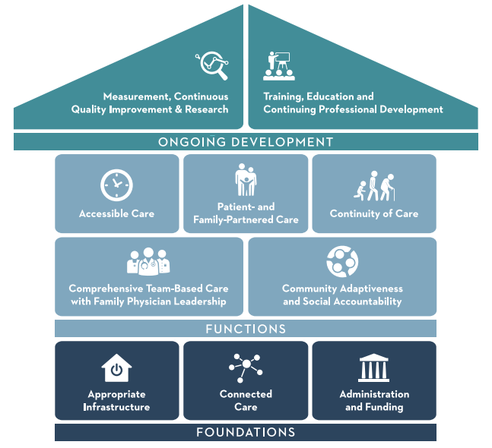
Foundations
- Administration and Funding
- Appropriate Infrastructure
- Connected Care
Functions
- Accessible Care
- Community Adaptiveness and Social Accountability
- Comprehensive Team-Based Care with Family Physician Leadership
- Continuity of Care
- Patient- and Family-Partnered Care
Ongoing Development
- Measurement, Continuous Quality Improvement, and Research
- Training, Education, and Continuing Professional Development (CPD)

Reviewing and referencing these resources is strongly encouraged while completing your nomination.

Remember, the implementation and modeling of the PMH is an ongoing effort. Those family practice clinics who show their dedication and commitment in actively pursuing the implementation of the PMH are still eligible to receive this recognition.

Patient’s Medical Home Award – Nomination Form

Questionnaire
The adjudication of each nomination is based on the breadth and depth of each nomination package. The answers provided to the following questions along with the attachment of any supplemental materials will be what the Member Engagement and Recognition Committee review.

Foundations – Establishing a PMH
  - ADMINISTRATION AND FUNDING | APPROPRIATE INFRASTRUCTURE | CONNECTED CARE
- With the first three pillars in mind, please identify the ways in which the nominee has established the foundations necessary to enable a PMH practice to thrive in their community?
<Type in this box or attach response on a separate sheet of paper (~250-500 words)>

Functions – Providing Exemplary PMH Care
  - ACCESSIBLE CARE | COMMUNITY ADAPTIVENESS AND SOCIAL ACCOUNTABILITY | COMPREHENSIVE TEAM-BASED CARE WITH FAMILY PHYSICIAN LEADERSHIP | CONTINUITY OF CARE | PATIENT- AND FAMILY-PARTNERED CARE
- Keeping in mind the five pillars associated with Functions, what remarkable contributions has the nominee implemented to providing exemplary PMH care?
<Type in this box or attach response on a separate sheet of paper (~250-500 words)>

Ongoing Development – Growing and Improving PMH Practices
  - MEASUREMENT, CONTINUOUS QUALITY IMPROVEMENT, AND RESEARCH | TRAINING, EDUCATION, AND CPD
- In considering the final two pillars, how does the nominee demonstrate its commitment to growing and improving PMH practices?
<Type in this box or attach response on a separate sheet of paper (~250-500 words)>

Going the Extra Mile
- Provide a specific example where the family practice has gone “above and beyond” the expectations of a family practice clinic.
(E.g., share the ways in which the family practice clinic has been adaptive, innovative, resourceful, and/or has demonstrated resilience when faced with adversity)
<Type in this box or attach response on a separate sheet of paper (~250-500 words)>

- Explain why this nominee deserves the Patient’s Medical Home Clinic Award.
<Type in this box or attach response on a separate sheet of paper (~250-500 words)>

sUPPLEMENTAL Materials
Although not mandatory, the following elements are strongly encouraged in the submission of a nomination package (up to 15 pages/10 attachments in length):
☐ Patient testimonials (two-three pages)
☐ Additional letters of support from peers, community organizations or groups, health professionals/administrators, etc. (two-three pages)
☐ Relevant media reports, pictures, etc. (one page)
For more information on the Awards program, visit https://bitly.com/acfp-awards

